30 winter Street, 6th Floor, Boston, MA 02108
P: 617.391.2700 | f: 617.391.2741
Census Participation Social Media Toolkit
An accurate census count helps ensure that all children and families get the resources and representation they deserve to help them reach their optimal health. But troublingly, children have been historically undercounted in the census, which can have a long-term impact on their overall health and well-being.
We’ve put together a collection of social media posts and graphics to help you encourage families to participate in the census. Use these posts on your own social channels to connect with families and prevent children from being undercounted. Make sure to tag @NICHQ so we can like and share your post.
Social Media Posts
- When you fill out the Census form, be sure to include all the people living in your home, including your children! Sesame Street has a special message about the importance of making your family count: https://www.youtube.com/watch?time_continue=24&v=KZmLI7eYjmw&feature=emb_title #Census2020

- Responding to the Census has never been easier! You can respond by mail, phone, or by visiting this link. Don’t forget to count everyone, from newborns to adults! https://www.2020census.gov/ #Census2020

- Every child counts! If the children in your home aren’t counted, especially between the ages of 0 to 5, the services they may need could be reduced or eliminated. Here, learn more information about the importance of the Census: https://www.nichq.org/insight/participate-census-promote-childrens-health#Census2020

- How do you want to shape the future? Watch this video on how the Census impacts funding that shapes many different aspects of every community, including school lunches, special education and much more! https://2020census.gov/en/community-impact.html #Census2020
Social Media Graphics
To save these graphics, exit “Read Only” mode, right click on each graphic and click “Save as Picture” to download!

**Avoid copy/pasting or screen-shots**
This will cause the image to be blurry when shared on social media

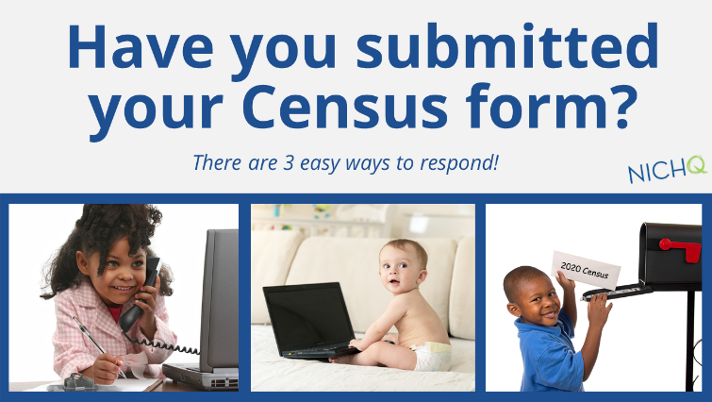

Click here for more information on encouraging census participation.

Share the toolkit with your colleagues and make sure to tag @NICHQ so we can like and share your post.
www.NICHQ.org

