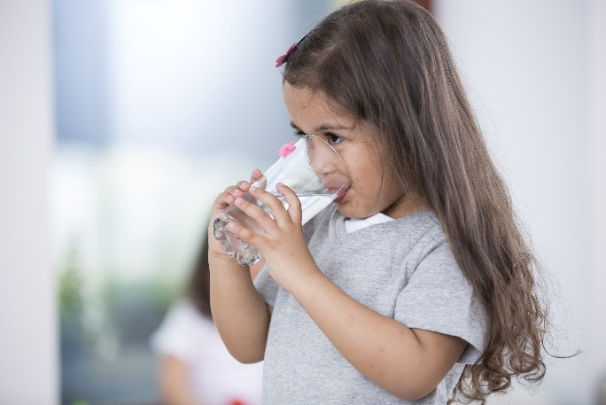

Lead Exposure and Children’s Health

Social Media Toolkit

Over 500,000 children in the U.S. have elevated blood lead levels. These children are more likely to have learning difficulties, behavior and speech problems, hearing loss, and other health and developmental concerns. At its highest levels, lead exposure can even result in death.
The good news is that childhood lead poisoning is 100 percent preventable. Use this social media toolkit to raise awareness and inspire change.

Social Posts

- Calling all pediatricians! Learn what you can do to help prevent lead exposure, identify and treat lead poisoning in patients, and advocate for public health measures to address the problem. https://www.aap.org/en-us/advocacy-and-policy/aap-health-initiatives/lead-exposure/Pages/Lead-Exposure-in-Children.aspx

- Did you know there is NO safe level of lead exposure for children? Learn more about prevention and treatment here. https://www.nichq.org/insight/are-your-hospitals-website-images-safe-sleep-friendly

- Children exposed to lead often won’t exhibit early symptoms. The American Academy of Pediatrics recommends regular lead risk assessments for children during their well child visits, which prompts early testing and interventions. https://www.aap.org/en-us/advocacy-and-policy/aap-health-initiatives/lead-exposure/Pages/Detection-of-Lead-Poisoning.aspx

- Lead can pervade children’s health environments, from chipped lead paint to drinking water to toys and jewelry. Understanding where lead comes from can help families keep their children safe. Learn more about the sources of lead here. https://www.cdc.gov/nceh/lead/prevention/sources.htm

- Childhood lead poisoning is 100 percent preventable. Get all the FAQs on lead prevention from the CDC here: https://www.cdc.gov/nceh/lead/faqs/lead-faqs.htm

- High blood levels during pregnancy can have significant health consequences, including causing a miscarriage or stillbirth. Learn the facts here: https://www.cdc.gov/nceh/lead/faqs/lead-faqs.htm

- Young children, pregnant women and children living below the poverty line are all at-risk for lead poisoning. Learn more about at-risk populations here: https://www.cdc.gov/nceh/lead/prevention/populations.htm

- In millions of homes across the U.S., children are living and playing while being exposed to the damaging effects of lead. Improving systems of care requires improving provider education. Read about a family who witnessed this need firsthand. https://www.nichq.org/insight/lead-poisoning-continues-put-too-many-children-risk

- Families are powerful advocates for system and policy improvements that address lead’s dangerous effects on children’s health. Here, learn how a parent-led advocacy group drove change across a Michigan city. (NICHQ link to come)

Graphics

Right click on each graphic and click “Save as Picture” to download!
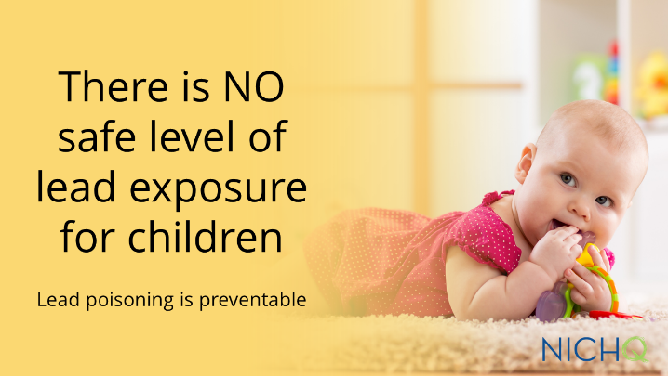
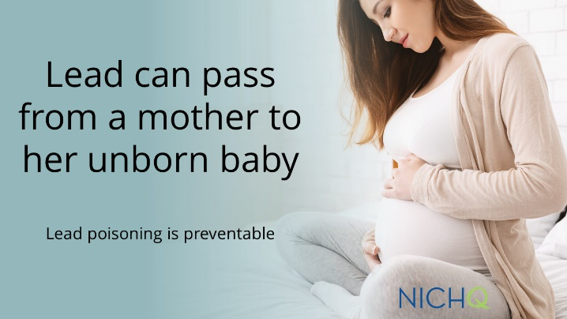
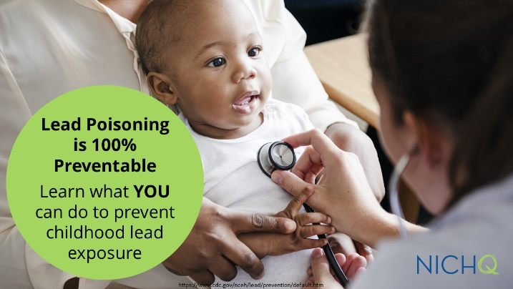
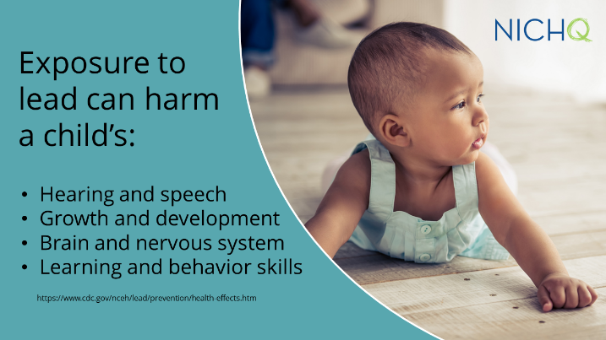
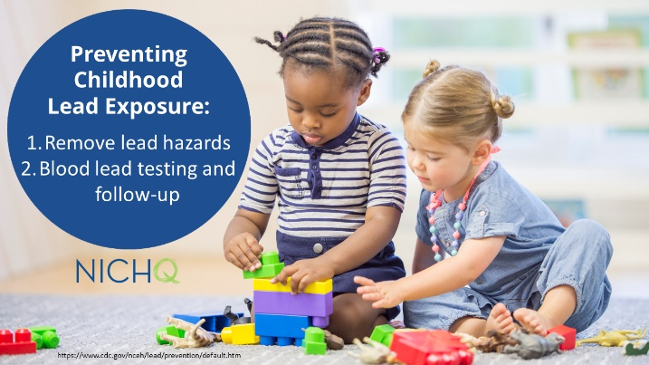
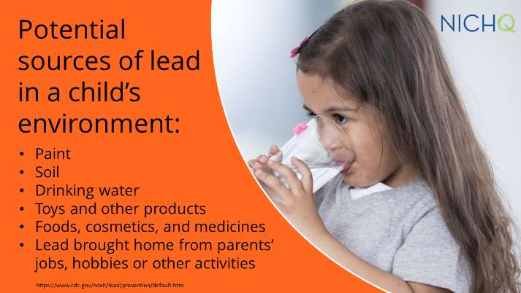

Download these graphics to use on your own social channels, and make sure to tag @NICHQ so we can like and share your post.

