Social Media Toolkit | May 2020

Mental Health Awareness Month

Mental health affects the overall health and well-being of children and families across the country. In recognition of Mental Health Awareness Month, we’ve put together a collection of social media posts and graphics. Use these to raise awareness and share resources that can change the way the world sees mental health.
One in five adults live with a mental illness, as well as millions of children. Mental Health Awareness Month is celebrated to fight stigma, provide support, educate the public and advocate for policies that support people with mental illness and their families.
Social Media Posts

- Help eliminate stigma that creates barriers for those living with mental health conditions and support the health of children and families. Change the way the world sees #mentalhealth by taking the StigmaFree pledge: https://www.nami.org/Get-Involved/Pledge-to-Be-StigmaFree/StigmaFree-Me/StigmaFree-Pledge @NAMI (Facebook), @NAMICommunicate (Twitter)

- We all likely know someone who has experienced mental illness. Yet there are still many harmful attitudes that fuel stigma and make it harder to reach out for help. Take the following quiz and test your #mentalhealth knowledge: https://www.cdc.gov/mentalhealth/quiz/index.htm @CDC (Facebook), @CDCgov (Twitter)

- The #COVID19 pandemic is stressful and may create new barriers to promoting #mentalhealth. That’s why @mentalhealthamerica is monitoring anxiety across the country and providing resources on supporting families during this difficult time: https://mhanational.org/covid19 @mentalhealthamerica (Facebook), @mentalhealtham (Twitter)

- Racial/ethnic, gender, and sexual minorities often suffer from poor mental health outcomes. The @AmericanPsychologicalAssociation is sharing factsheets that provide a snapshot of the current state of #mentalhealth of minority populations: https://www.psychiatry.org/psychiatrists/cultural-competency/education/mental-health-facts @AmericanPsychologicalAssociation (Facebook), @APA (Twitter)

- How can we help dads be the best fathers possible? Supporting their mental health is one way to start. Here, @NICHQ shares four strategies that health care providers and public health professionals can use to advocate for fathers’ #mentalhealth: https://www.nichq.org/insight/promoting-fathers-mental-health-during-childrens-early-childhood

- Ensuring a strong support system and access to treatment can help mothers overcome maternal depression. This @NICHQ resource highlights stories about developing systems for screening for maternal depression and providing follow-up treatment: https://www.nichq.org/resource/designing-systems-eliminate-consequences-maternal-depression

- When caregivers suffer from depression, it impacts their ability to provide the care and attention their child needs to thrive. This brief provides fact sheets on the key strategies and information influencers need to help more caregivers access supportive interventions: https://www.nichq.org/resource/fast-facts-champion-support-caregiver-depression

- One in 5 adults live with a mental illness, as well as millions of children. @mentalhealthamerica is sharing toolkits, handouts, and other resources to raise awareness about #mentalhealth. https://www.mhanational.org/mental-health-month @mentalhealthamerica (Facebook), @mentalhealtham (Twitter)

Graphics
To save these graphics, exit “Read Only” mode, right click on each graphic and click “Save as Picture” to download!

**Avoid copy/pasting or screen-shots**
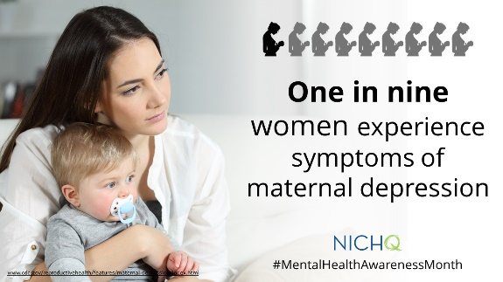
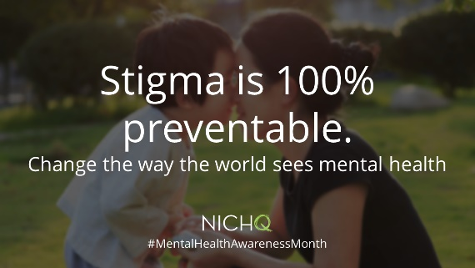
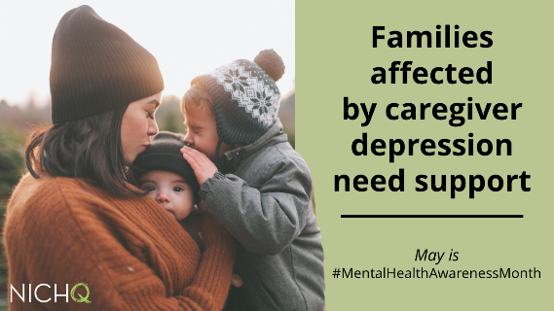
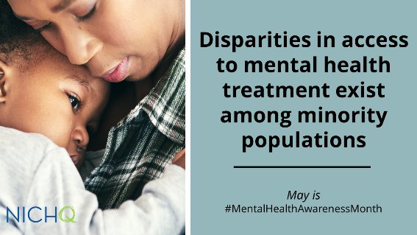
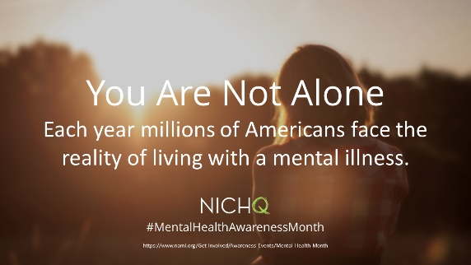
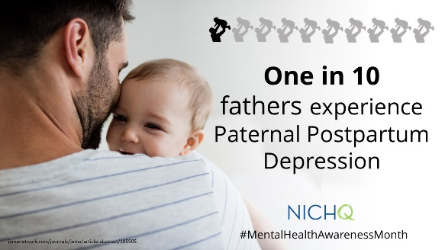
This will cause the image to be blurry when shared on social media

Download these graphics to use on your own social channels, and make sure to tag @NICHQ so we can like and share your post.

