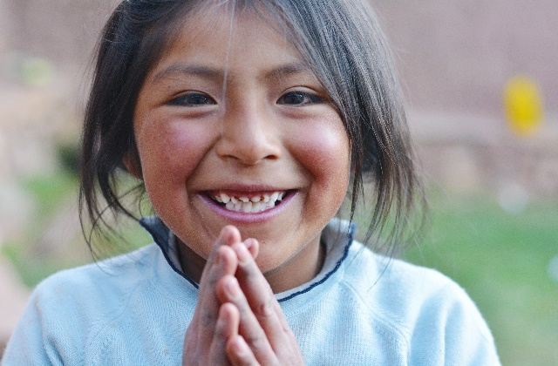

Social Media Toolkit | April 2020

National Minority Health Month

In recognition of National Minority Health Month, we’ve put together a collection of social media posts and graphics. Use these to raise awareness about racial and ethnic disparities and the need to achieve health equity. Download the toolkit to use on your own social channels and make sure to tag @NICHQ so we can like and share your post.

By addressing racism as a public health issue, we are one step closer to achieving health equity and improving health outcomes for all children and families throughout the country.
Social Media Posts
- The theme for National Minority Health Month is Active & Healthy. Incorporating small amounts of moderate-to-vigorous physical activity can improve health outcomes of those impacted by chronic diseases. View the @minorityhealth campaign here: https://www.minorityhealth.hhs.gov/omh/Content.aspx?ID=12481&lvl=2&lvlid=12 #NMHM20

- All babies should have the opportunity to celebrate their first birthday. Whether you’re a grandparent, daycare provider, or other caregiver, these resources can provide you with the knowledge you need to feel confident caring for the babies in your life: https://www.firstyearcleveland.org/take-action/families-caregivers-community
Facebook: @firstyearcleveland Twitter: @FirstYearCLE #NMHM20

- Black and American Indian/Alaska Native babies are dying at more than twice the rate of white babies. Learn from these promising practices that aim to eliminate #disparities in sleep-related infant deaths: https://www.nichq.org/insight/promising-practices-eliminating-disparities-sleep-related-infant-deaths #NMHM20 #healthequity #safesleep #sids

- Policies can play a vital role in improving health outcomes for racial and ethnic minority groups. Here are tools and resources to help you advocate for #healthequity in your community: https://www.aafp.org/patient-care/social-determinants-of-health/everyone-project/advocacy.html Facebook: @familymed Twitter: @aafp #NMHM20

- Racial and ethnic discrimination can negatively affect health across lifetimes and generations. Here, explore the connections between race, racism, and health in the United States: https://www.rwjf.org/en/library/collections/racism-and-health.html #NMHM20

- Lower breastfeeding rates among Black women reflect historic and systemic #inequities. Here, read about a #breastfeeding peer-support network working to close the gap: https://www.nichq.org/insight/breastfeeding-takes-village-and-too-often-black-women-dont-have-one #NMHM20

- Not everyone in the U.S. has a fair opportunity to be healthy. One thing we can each do to eliminate health #disparities is address our own implicit bias. Use this Implicit Bias Resource Guide to get started. https://www.nichq.org/resource/implicit-bias-resource-guide #NMHM20

- Black women are dying from pregnancy-related deaths at over four times the rate of white women. This article shares seven strategies for reducing maternal mortality and promoting #equity: https://www.nichq.org/insight/using-equity-lens-reduce-maternal-mortality-louisiana #healthequity #NMHM20
Graphics

To save these graphics, exit “Read Only” mode, right click on each graphic and click “Save as Picture” to download!

Download these graphics to use on your own social channels, and make sure to tag @NICHQ so we can like and share your post.

**Avoid copy/pasting or screen-shots**
This will cause the image to be blurry when shared on social media

