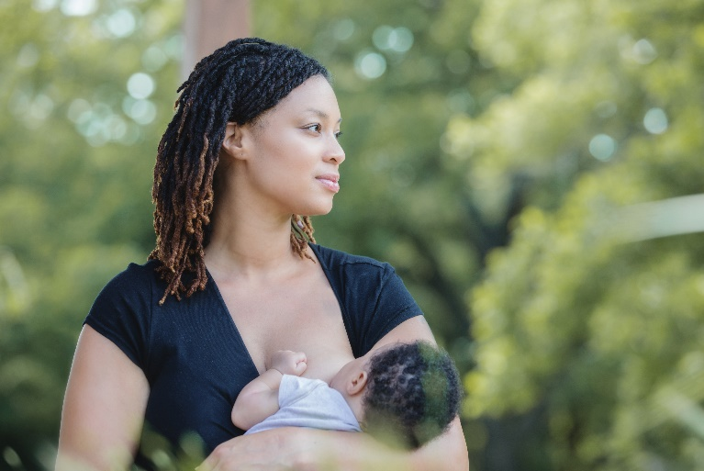
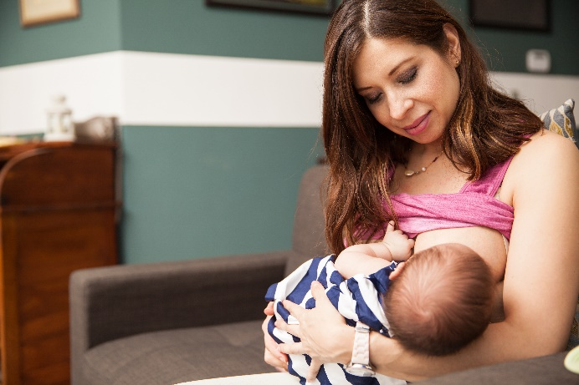

National Breastfeeding Awareness Month

Social Media Toolkit | August 2019

In recognition of National Breastfeeding Awareness Month, we’ve put together a collection of social media posts and graphics that can be used to raise awareness about the importance and benefits of breast milk, as well as empower and support all mothers to achieve their breastfeeding goals.
National Breastfeeding Month is celebrated to advance advocacy, protection and promotion of breastfeeding to ensure that all families have the opportunity to breastfeed.

Twitter
- Breast milk produced at the end of pregnancy is the perfect food for a newborn—that’s why @WHO recommends initiating feeding within the first hour of birth. #BreastfeedingAwarenessMonth @NICHQ
https://www.who.int/features/factfiles/breastfeeding/en/

- Mothers need a safe, clean and private area to breastfeed or pump. Having these environments in the workplace can help mothers reach their breastfeeding goals after they’ve returned to work. #BreastfeedingAwarenessMonth @NICHQ
https://www.cdc.gov/breastfeeding/pdf/BF_guide_2.pdf

- Not only is breastfeeding good for babies, but it’s good for mothers too! Learn more about the health benefits and practical advantages of breastfeeding. #BreastfeedingAwarenessMonth @NICHQ
https://www.healthychildren.org/English/ages-stages/baby/breastfeeding/Pages/Benefits-of-Breastfeeding-for-Mom.aspx

- Do you know how much and how often babies should be breastfed during the first days, weeks and months of life? Learn here! #BreastfeedingAwarenessMonth @NICHQ
https://www.cdc.gov/nutrition/infantandtoddlernutrition/breastfeeding/how-much-and-how-often.html

- Having breast surgery often doesn’t preclude individuals from producing some milk. Visit the link for more insight on breast surgeries and their impact on breastfeeding or chestfeeding: #BreastfeedingAwarenessMonth @NICHQ https://www.cdc.gov/breastfeeding/breastfeeding-special-circumstances/maternal-or-infant-illnesses/breast-surgery.html

- Traveling shouldn’t prevent mothers from breastfeeding. Families that understand how to express, store and transport their breast milk can continue to breastfeed while away from home: #BreastfeedingAwarenessMonth @NICHQ https://www.cdc.gov/nutrition/infantandtoddlernutrition/breastfeeding/travel-recommendations.html

- It’s not always easy for mothers to get the support they may need while breastfeeding. Read how telelactation can provide mothers with online lactation consultants, support groups and other essential resources. #BreastfeedingAwarenessMonth @NICHQ https://www.nichq.org/insight/bringing-breastfeeding-support-more-mothers-and-caregivers

- The CDC shares tips on how to provide both prenatal and postpartum support to transgender parents who wish to breastfeed or chestfeed their infant: #BreastfeedingAwarenessMonth @NICHQ https://www.cdc.gov/breastfeeding/breastfeeding-special-circumstances/maternal-or-infant-illnesses/breast-surgery.html
Facebook / Linked In

- Mothers can have many concerns about breastfeeding, especially in the early days. As health care professionals, it’s important to learn about the common challenges mothers experience so you can provide the support they need. @NICHQ https://www.womenshealth.gov/breastfeeding/breastfeeding-challenges/common-breastfeeding-challenges

- Not only does rooming-in have the potential to improve health outcomes for mothers and babies, but it has the potential to reduce racial disparities in breastfeeding. Learn more about how this strategy can improve rates of breastfeeding for all. @NICHQ https://www.nichq.org/insight/interrupting-mother-childdyad-not-answer-infant-safety

- Breast milk translates to better outcomes for premature babies, but they may have difficulty feeding due to being too small or sick. Learn how a New York State hospital overcame barriers and increased breast milk provision. @NICHQ https://www.nichq.org/insight/neonatologist-shares-successful-strategies-improving-infant-health-outcomes

- Younger moms (aged 20 to 29 years) and adolescent mothers are less likely to ever breastfeed than mothers aged 30 years or older. Building resiliency in young moms can improve breastfeeding and save babies. @NICHQ https://www.nichq.org/insight/building-resiliency-teen-moms-can-improve-breastfeeding-and-save-babies

- Breast milk is the best source of nutrition for most babies, providing a variety of vitamins and minerals that help babies grow big and strong! Empower mothers to learn about the benefits of breast milk. @NICHQ
https://www.cdc.gov/nutrition/InfantandToddlerNutrition/breastfeeding/index.html

- Reducing racial and ethnic disparities in breastfeeding starts with providing families with education and support services that meet their social, cultural and linguistic needs. Learn how cultural sensitivity improves breastfeeding outcomes. @NICHQ
https://www.nichq.org/insight/cultural-sensitivity-better-breastfeeding-outcomes

- It’s not always easy for mothers to get the support they may need while breastfeeding. Read how telelactation can provide mothers with online lactation consultants, support groups and other essential resources. @NICHQ https://www.nichq.org/insight/bringing-breastfeeding-support-more-mothers-and-caregivers

Graphics

Right click on each graphic and click “Save as Picture” to download!

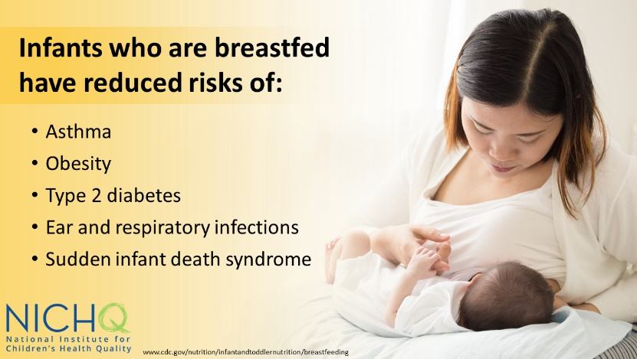
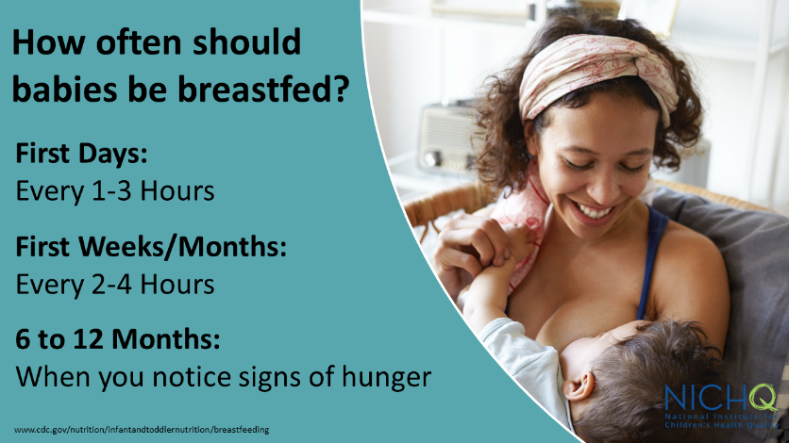
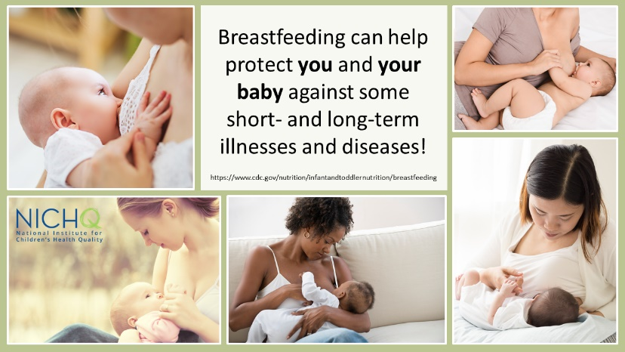
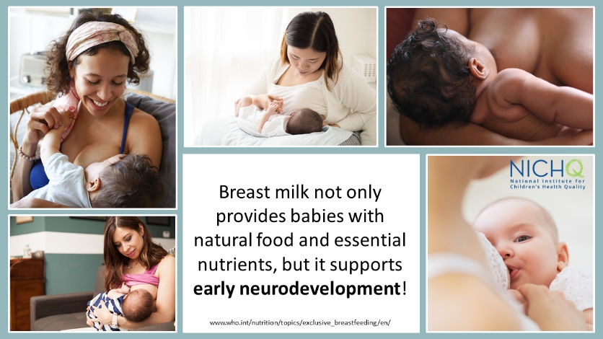
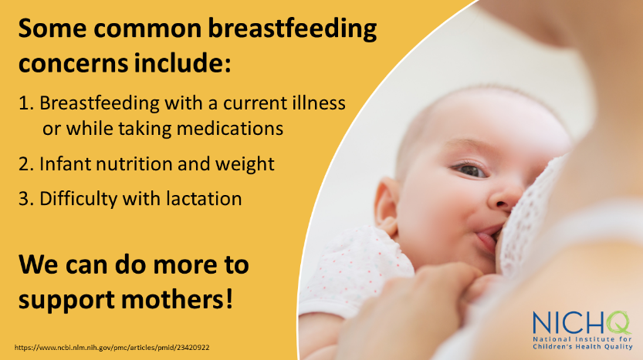
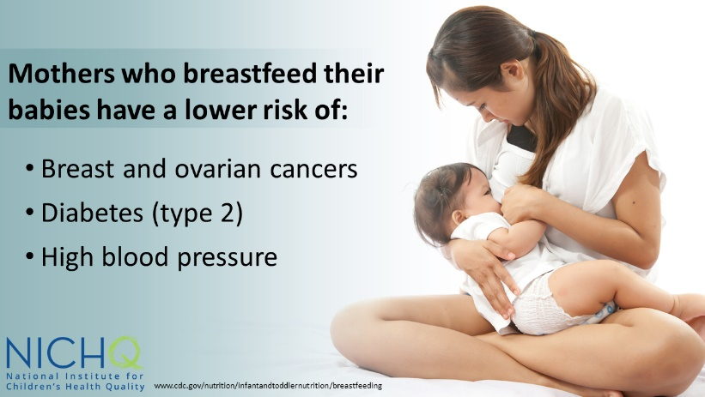

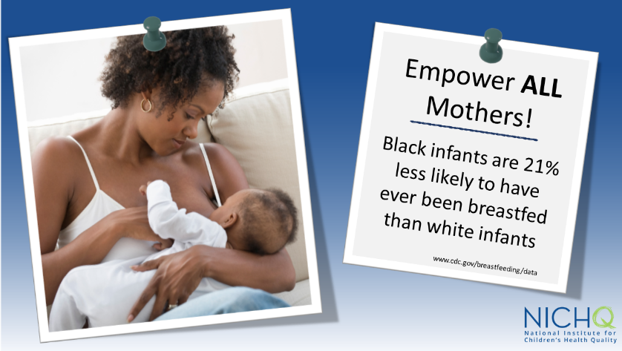
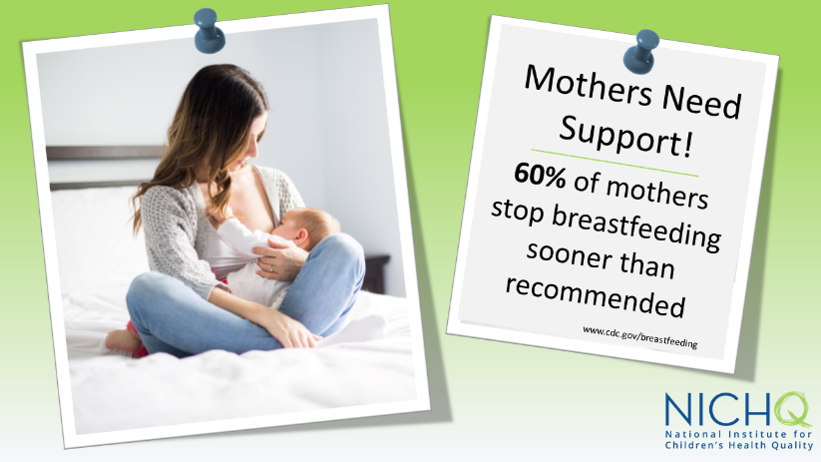
Download these graphics to use on your own social channels, and make sure to tag @NICHQ so we can like and share your post.

