Social Media Toolkit | October 2019

National SIDS Awareness Month

In recognition of National Sudden Infant Death Syndrome (SIDS) Awareness Month, we’ve put together a collection of social media posts and graphics that can be used to raise awareness about SIDS, sleep-sleep related deaths and to help babies sleep safely.
With about 3,500 sleep-related deaths among US babies each year, so National SIDS Awareness Month is celebrated to advance advocacy, protection and promotion of evidence based safe-sleep practices to ensure that all babies are sleeping safely.
Twitter
- Learn how hospitals can empower families to practice safe sleep and work towards making safe sleep and breastfeeding the national norm: #SafeSleep #Breastfeeding https://www.nichq.org/insight/three-ways-hospitals-can-help-eliminate-sleep-related-infant-deaths-their-state

- Are your hospital’s website images safe-sleep friendly? Learn how updating images on hospital websites across your state can avoid mixed messages about safe infant sleep. #SUID #SIDs #SafeSleep https://www.nichq.org/insight/are-your-hospitals-website-images-safe-sleep-friendly

- How safe sleep savvy are you? Take this short interactive video quiz, then share with other health professionals! This quiz can be used to engage caregivers in conversations about #safesleep AND #breastfeeding recommendations. https://www.nichq.org/resource/how-safe-sleep-savvy-are-you

- Learn how consistent, evidence-based advice on #safesleep and #breastfeeding could improve maternal and infant health outcomes, save babies’ lives, and address significant racial disparities. https://www.nichq.org/insight/one-step-closer-national-norm-infant-safe-sleep-and-breastfeeding

- For National Breastfeeding Month, the Safe to Sleep® campaign is highlighting how breastfeeding can help reduce the risk of Sudden Infant Death Syndrome #SIDS. View their handout that provides tips on breastfeeding and safe infant sleep: @NICHD_NIH https://www.nichd.nih.gov/sites/default/files/2018-11/Breastfeed_Baby_SIDS_final.pdf

- What does a Safe Sleep environment look like? The Safe to Sleep campaign is offering an interactive toolkit that helps parents and caregivers learn how to create a safe sleep environment for their baby. Access the toolkit here: https://safetosleep.nichd.nih.gov/resources/caregivers/environment/room

- Babies that sleep in an adult bed or couch with a parent or caregiver are at a higher risk of SIDS. Learn about the strategies that reduce bed sharing while reinforcing the advantages of breastfeeding: https://www.nichq.org/insight/bedsharing-breastfeeding-and-babies-dying-conversation-worth-having

- Swaddling has been a popular practice for generations because it comforts babies and promotes sleep. Learning the correct way to swaddle a baby and practicing the proper techniques reduces the risk of sleep-related deaths. #SafeSleep #Swaddling https://www.nichq.org/insight/health-professionals-need-talk-families-about-swaddling
Facebook / LinkedIn

- Hospitals in a national initiative to improve #SafeSleep education recently shared their highest-rated strategies and change ideas. Access the full list here. #SIDS #SUID https://www.nichq.org/insight/successful-strategies-hospitals-can-use-support-safe-sleep

- How safe sleep savvy are you? Take this short interactive video quiz, then share with other health professionals! This quiz can be used to engage caregivers in conversations about #safesleep AND #breastfeeding recommendations. https://www.nichq.org/resource/how-safe-sleep-savvy-are-you

- Many states are leveraging home visiting programs as a way to spread information and strategies related to safe sleep practices. Learn how home visiting programs can be a keey component to reducing SIDS: https://www.nichq.org/insight/states-use-home-visiting-programs-spread-safe-sleep-messages

- By addressing unsafe sleep practices within underserved populations, we can eliminate persistent disparities in SIDS rates and reduce infant mortality for all. Here, learn how we can close the gap in safe sleep education in underserved communities. https://www.nichq.org/insight/closing-gaps-safe-sleep-education-underserved-populations

- By providing more resources tailored to populations experiencing higher rates of SIDS, we can decrease preventable deaths. Access a safe-sleep promising practices here: https://www.nichq.org/insight/promising-practices-eliminating-disparities-sleep-related-infant-deaths

Graphics

To save these graphics, exit “Read Only” mode, right click on each graphic and click “Save as Picture” to download!

**Avoid copy/pasting or screen-shots**
This will cause the image to be blurry when shared on social media
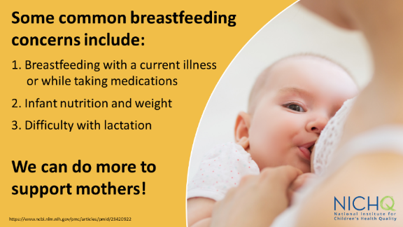
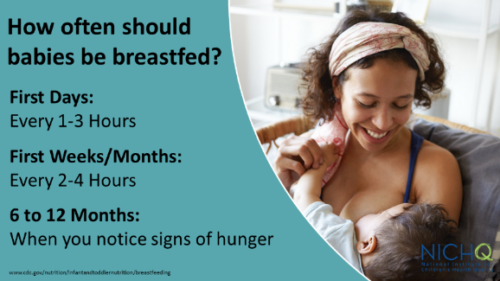

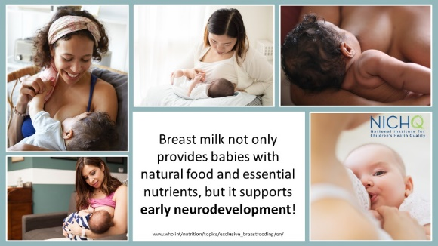
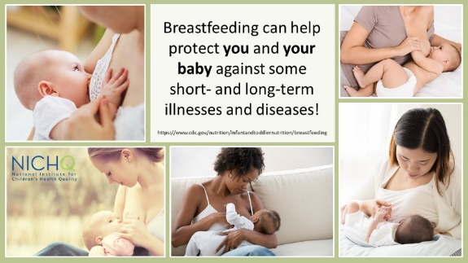

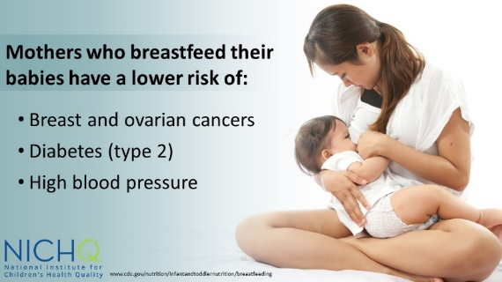
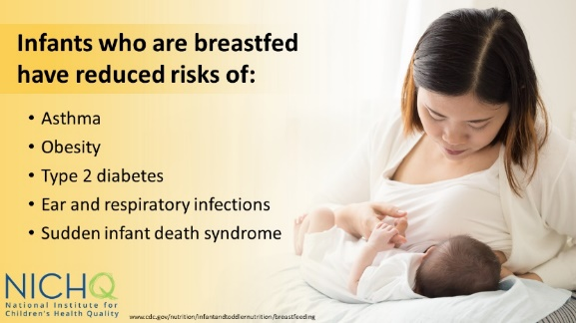

Download these graphics to use on your own social channels, and make sure to tag @NICHQ so we can like and share your post.

