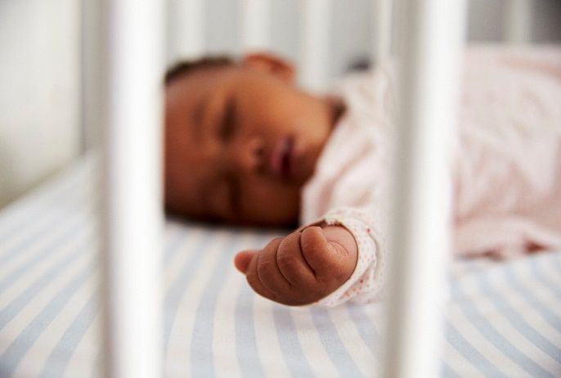
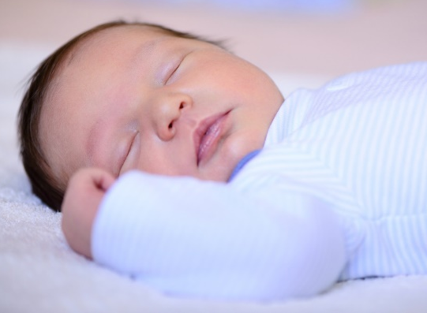

Social Media Toolkit | October 2019

National SIDS Awareness Month

In recognition of National Sudden Infant Death Syndrome (SIDS) Awareness Month, we’ve put together a collection of social media posts and graphics. Use these to raise awareness about SIDS and safe-sleep related deaths so that more babies reach year one.
With approximately 3,600 sleep-related deaths among U.S. babies each year, National SIDS Awareness Month is celebrated to advance advocacy, protection and promotion of evidence-based safe-sleep practices to ensure that all babies are sleeping safely.

Twitter

- Helping parents create a safe sleep environment can reduce the risk of SIDS and save thousands of babies. Learn about safe sleep guidelines here. #SIDSAwarenessMonth
https://pediatrics.aappublications.org/content/pediatrics/138/5/e20162938.full.pdf

- American Indian/Alaskan Native and Non-Hispanic Black Babies die from sleep-related deaths at more than twice the rate of white babies. Eliminating disparities can help more babies reach year one. #SIDSAwarenessMonth https://www.cdc.gov/sids/data.htm

- Learn how hospitals can empower families to practice safe infant sleep and work towards making safe sleep and breastfeeding the national norm: #SafeSleep #Breastfeeding #SIDSAwarenessMonth #https://www.nichq.org/insight/three-ways-hospitals-can-help-eliminate-sleep-related-infant-deaths-their-state

- Are your hospital’s website images safe sleep friendly? Learn how updating images on hospital websites across your state can eliminate mixed messages about safe infant sleep. #SafeSleep #SIDSAwarenessMonth https://www.nichq.org/insight/are-your-hospitals-website-images-safe-sleep-friendly

- How safe sleep savvy are you? This short interactive quiz can be used to engage caregivers in conversations about #safesleep AND #breastfeeding recommendations. #SIDSAwarenessMonth https://www.nichq.org/resource/how-safe-sleep-savvy-are-you

- Learn how consistent, evidence-based advice on #safesleep and #breastfeeding can improve maternal and infant health outcomes, save babies’ lives, and reduce significant racial disparities. #SIDSAwarenessMonth https://www.nichq.org/insight/one-step-closer-national-norm-infant-safe-sleep-and-breastfeeding

- What does a Safe Sleep environment look like? The Safe to Sleep® campaign offers an interactive toolkit that helps parents and caregivers learn how to create a safe sleep environment for their baby. Access the toolkit here: @NICHD_NIH https://safetosleep.nichd.nih.gov/resources/caregivers/environment/room

- The Safe to Sleep® campaign is hosting a #SafeSleepSnap photo activity for #SIDSAwarenessMonth. Learn how to participate here. @NICHD_NIH
https://safetosleep.nichd.nih.gov/resources/sids-awareness-toolkit

Facebook / LinkedIn

- Having caregivers practice evidence-based safe sleep recommendations is key to reducing the risk of SIDS and other sleep-related deaths. Access the @AmerAcadPeds full list of safe sleep recommendations here. #SIDSAwarenessMonth https://www.aap.org/en-us/advocacy-and-policy/aap-health-initiatives/healthy-child-care/Pages/Safe-Sleep.aspx

- Unsure if your crib is safety approved? Here, learn how to make your babies’ crib a safe sleep environment along with other recommendations to prevent SIDS. #SafeSleep #SIDSAwarenessMonth https://www.cdc.gov/sids/Parents-Caregivers.htm

- Hospitals in a national initiative to improve #safesleep education recently shared their highest-rated strategies and change ideas. Access the full list here. #SIDS #SIDSAwarenessMonth https://www.nichq.org/insight/successful-strategies-hospitals-can-use-support-safe-sleep

- How safe sleep savvy are you? Take this short interactive video quiz, then share it with other health professionals! This quiz can be used to engage caregivers in conversations about #safesleep AND #breastfeeding recommendations. #SIDSAwarenessMonth https://www.nichq.org/resource/how-safe-sleep-savvy-are-you

- Providing more resources tailored to underserved populations experiencing higher rates of SIDS can decrease preventable deaths. These promising practices can be used to reduce #SIDS and drive community, state and national change. #SIDSAwarenessMonth https://www.nichq.org/insight/promising-practices-eliminating-disparities-sleep-related-infant-deaths

- The Safe to Sleep® campaign has created a 12-page brochure that informs caregivers about #SIDS and strategies to reduce the risk of #SIDS and other sleep-related causes of infant death. Access their resource here. @NICHD_NIH #SIDSAwarenessMonth https://safetosleep.nichd.nih.gov/resources/caregivers

- Babies who are breastfed or are fed expressed breastmilk are at lower risk for #SIDS compared with babies who were never fed breastmilk. Here, learn more about the impact of breastfeeding on infant health: @NICHD_NIH #SIDSAwarenessMonth https://www.nichd.nih.gov/sites/default/files/2018-11/Breastfeed_Baby_SIDS_final.pdf

- To help raise awareness about safe infant sleep during SIDS Awareness Month in October, the Safe to Sleep® Campaign is inviting you to participate in a fun and friendly photo activity. Learn more about the activity here: @NICHD_NIH #SafeSleepSnap #SIDSAwarenessMonth https://safetosleep.nichd.nih.gov/resources/sids-awareness-toolkit
Graphics

Right click on each graphic and click “Save as Picture” to download!

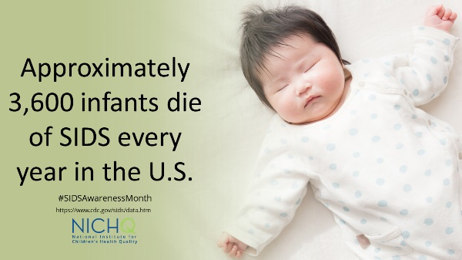
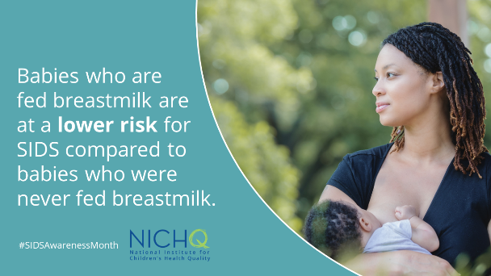
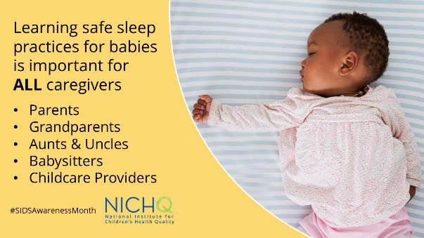
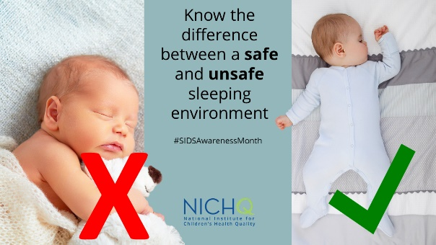
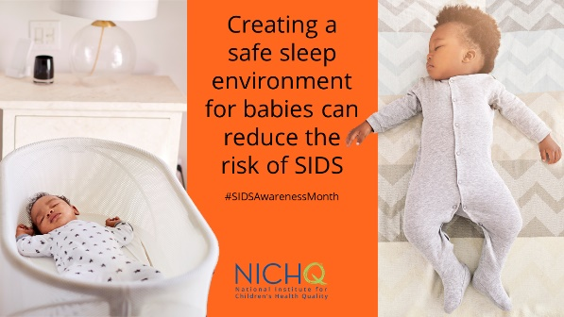
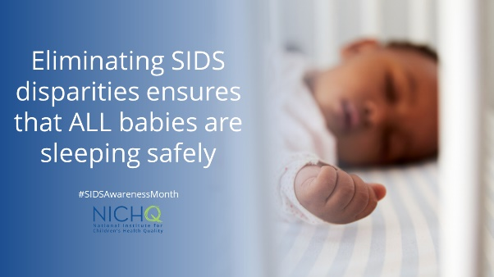

Download these graphics to use on your own social channels, and make sure to tag @NICHQ so we can like and share your post.

