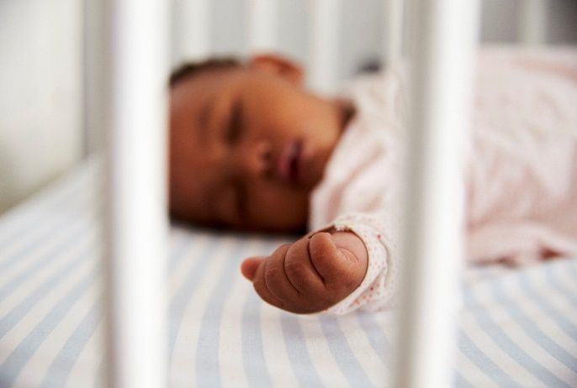
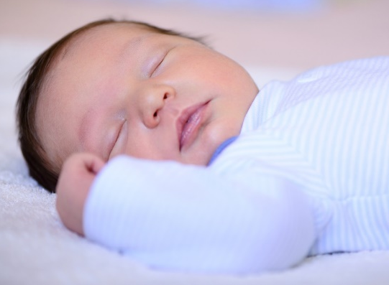

Social Media Toolkit | October 2020

National SIDS Awareness Month

In recognition of National Sudden Infant Death Syndrome (SIDS) Awareness Month, we’ve put together a collection of social media posts and graphics. Use these to raise awareness about SIDS and safe-sleep related deaths so that more babies reach year one.
With approximately 3,500 sleep-related deaths among U.S. babies each year, National SIDS Awareness Month is celebrated to advance advocacy, protection and promotion of evidence-based safe-sleep practices to ensure that all babies are sleeping safely.

Twitter

- During the #COVID-19 pandemic, parents may experience increased stress and fatigue that could affect their ability to ensure that their baby is sleeping safely. Learn how to reduce your baby’s risk of sudden infant death syndrome (SIDS) and other sleep-related deaths here: https://www.cdc.gov/coronavirus/2019-ncov/need-extra-precautions/pregnancy-breastfeeding.html

- Black families are twice as likely as white families to have their baby die in the first year of life. Here, faculty experts on a national safe sleep and breastfeeding initiative share their recommendations for how health professionals and improvement initiatives can better support the health and well-being of black families: https://www.nichq.org/insight/applying-equity-lens-safe-sleep-and-breastfeeding-efforts
- Helping parents create a #safesleep environment can reduce the risk of SIDS and save thousands of babies. Learn about updated safe sleep guidelines here: https://pediatrics.aappublications.org/content/pediatrics/138/5/e20162938.full.pdf

- Are your hospital’s website images #safesleep friendly? Learn how updating images on hospital websites across your state can eliminate mixed messages about safe infant sleep. https://www.nichq.org/insight/are-your-hospitals-website-images-safe-sleep-friendly

- How safe sleep savvy are you? This short interactive quiz can be used to engage caregivers in conversations about #safesleep and #breastfeeding recommendations: https://www.nichq.org/resource/how-safe-sleep-savvy-are-you

- Learn how consistent, evidence-based advice on #safesleep and #breastfeeding can improve maternal and infant health outcomes, save babies’ lives, and reduce significant racial disparities: https://www.nichq.org/insight/one-step-closer-national-norm-infant-safe-sleep-and-breastfeeding

- What does a safe sleep environment look like? The Safe to Sleep® campaign offers an interactive toolkit that helps parents and caregivers learn how to create a #safesleep environment for their baby. Access the toolkit here: https://safetosleep.nichd.nih.gov/resources/caregivers/environment/room

- Having caregivers practice evidence-based safe sleep recommendations is key to reducing the risk of SIDS and other sleep-related deaths. Access the @AmerAcadPeds full list of #safesleep recommendations here. https://www.aap.org/en-us/advocacy-and-policy/aap-health-initiatives/healthy-child-care/Pages/Safe-Sleep.aspx

- Unsure if your crib is safety approved? Here, learn how to make your babies’ crib a #safesleep environment along with other recommendations to prevent SIDS. https://www.cdc.gov/sids/Parents-Caregivers.htm

- Providing more resources tailored to underserved populations experiencing higher rates of SIDS can decrease preventable deaths. These promising practices can be used to reduce SIDS and drive community, state and national change: https://www.nichq.org/insight/promising-practices-eliminating-disparities-sleep-related-infant-deaths

- The Safe to Sleep® campaign has created a brochure that informs caregivers about SIDS and strategies to reduce the risk of #SIDS and other sleep-related causes of infant death. Access their resource here: https://safetosleep.nichd.nih.gov/resources/caregivers

- Babies who are breastfed or are fed expressed breastmilk are at lower risk for SIDS compared with babies who were never fed breastmilk. Here, learn more about the impact of breastfeeding on infant health: https://www.nichd.nih.gov/sites/default/files/2018-11/Breastfeed_Baby_SIDS_final.pdf

- To help raise awareness about safe infant sleep during SIDS Awareness Month in October, the Safe to Sleep® Campaign is inviting you to participate in a fun and friendly photo activity. Learn more about the activity here: https://safetosleep.nichd.nih.gov/resources/sids-awareness-toolkit

Graphics
To save these graphics, exit “Read Only” mode, right click on each graphic and click “Save as Picture” to download!

**Avoid copy/pasting or screen-shots**
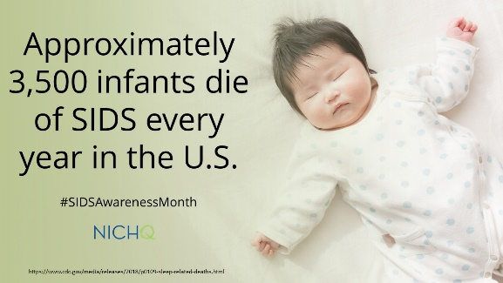
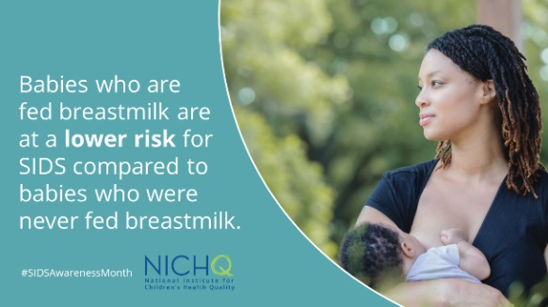
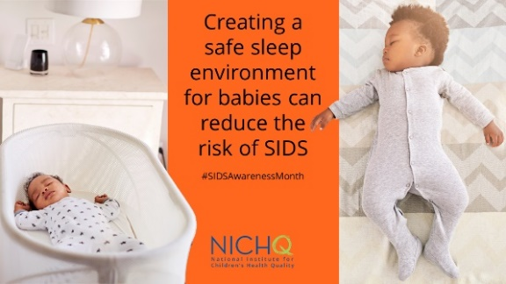
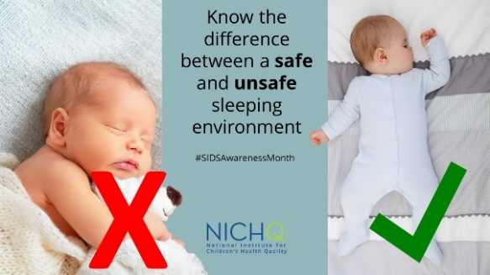
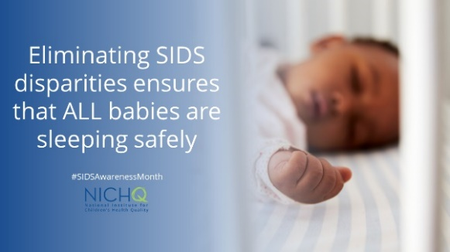
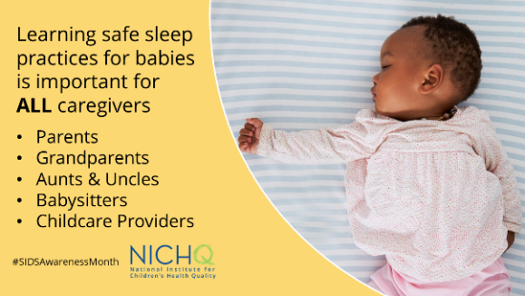
This will cause the image to be blurry when shared on social media
Download these graphics to use on your own social channels, and make sure to tag @NICHQ so we can like and share your post.

