Social Media Toolkit | Feb. 29, 2020

Rare Disease Day

On the rarest of dates—Feb. 29—, we’re inviting our network to join NICHQ in raising awareness about uncommon diseases and innovative ideas for improving health outcomes. We’ve put together a collection of social media posts, graphics, and images sharing key statistics and facts that illustrate the impact rare diseases have on over 25 million Americans.

Share the toolkit with your colleagues and use it yourself on Rare Disease Day on February 29, 2020.

Social Media Posts
- One in 20 people will live with a #raredisease at some point in their life. Troublingly, a majority of these diseases have no cure. Learn how you can spread knowledge about these conditions and encourage researchers and decision-makers to address the needs of those living with rare diseases: https://www.rarediseaseday.org/article/what-is-rare-disease-day #RareDiseaseDay

- In the United States, a #raredisease is defined as one that affects fewer than 200,000 people. Looking to learn more about rare diseases? Visit the link for more information about rare diseases and what causes them: https://rarediseases.info.nih.gov/diseases/pages/31/faqs-about-rare-diseasesc #RareDiseaseDay
  - Facebook Handle Tag: @ORDRNCATS
  - Twitter Handle Tag: @ORDR

- The National Organization for Rare Disorders provides resources for patient and caregivers, including educational videos, webinars, and downloadable fact sheets. Access these resources here: https://rarediseases.org/for-patients-and-families/information-resources/patient-and-caregiver-resource-center/ #RareDiseaseDay
  - Facebook Handle Tag: @NationalOrganizationforRareDisorders
  - Twitter Handle Tag: @RareDisease

- Wondering how to become a #raredisease champion in your community? With close to 7,000 rare diseases without a treatment, advocacy efforts in your community can lead to policy and research that could result in a cure: https://rarediseases.org/advocate/policy-priorities/issues/ #RareDiseaseDay

- The #RareDiseaseDay campaign is providing information packets, posters, and other guides to promote the spread of #raredisease knowledge. Access these tools here: https://www.rarediseaseday.org/downloads

- Those living with rare diseases often struggle to access quality care. Learn about a telementoring initiative that is transforming provider training to enhance care delivery and improve access to care for #sicklecelldisease patients across the country: https://www.nichq.org/insight/innovation-provider-training-increases-access-care-sickle-cell-disease-patients #RareDiseaseDay #SCD
- Millions of American children are living with a #raredisease. NICHQ President and CEO Scott D. Berns shares his professional and personal connection to the rare disease community and urges increased national attention. https://www.nichq.org/insight/rare-diseases-deserve-our-attention #RareDiseaseDay

- Transitioning from pediatric to adult health care can be complicated for those born with chronic conditions. These strategies for helping young adults with #sicklecelldisease transition to adult care can save lives: https://www.nichq.org/insight/improving-transitions-care-saves-lives #RareDiseaseDay #SCD
Graphics

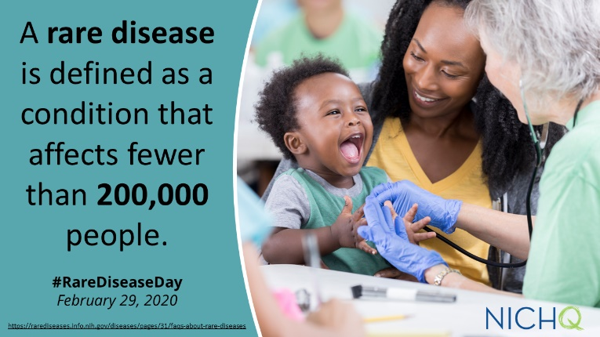
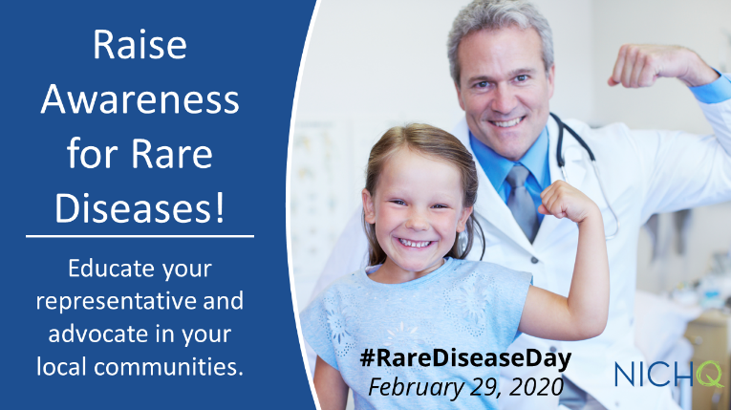
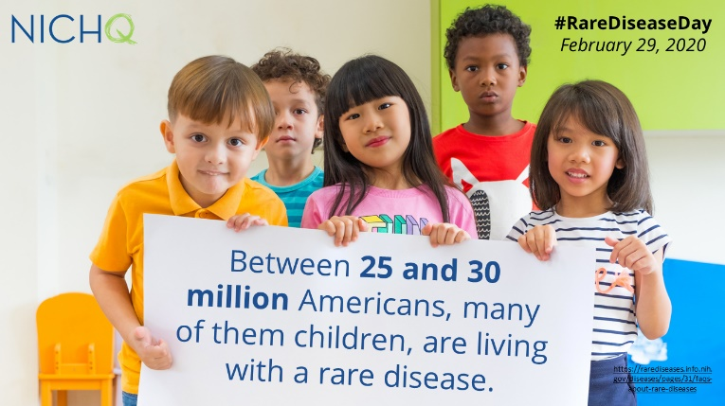
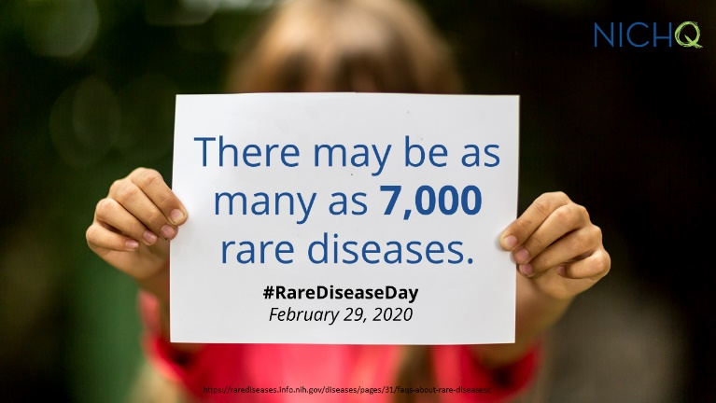
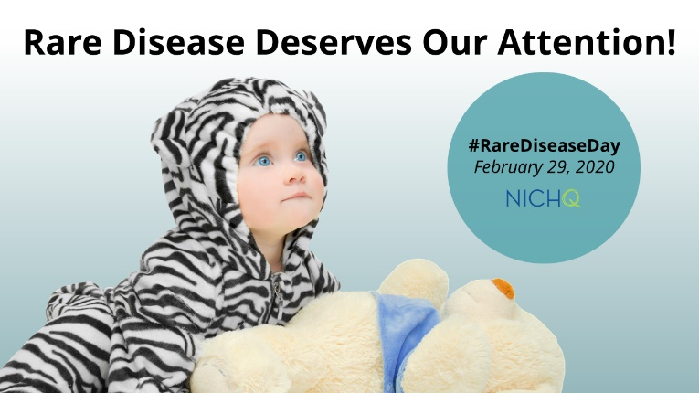
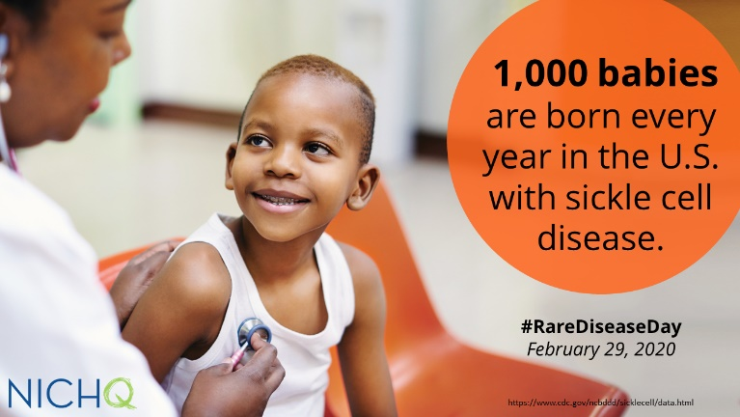
Right click on each graphic and click “Save as Picture” to download!

Download these graphics to use on your own social channels, and make sure to tag @NICHQ so we can like and share your post.

